Sys-Api’s:

System-Api’s. This layer is exposed to software. This contains all the

SIM API’s:

Covering all of the features of the sim api’s is beyond me but I can explain the general flow.

- Run_test_0
- Run_test_1
- Run_test_2 …..

First it is declared with extern and that implies the implementation of the function lies elsewhere. Hint: It’s in the test.c

So, how do we run these test’s & link them to UVM threads ?

We use a macro “RUN_TEST(idx)” and that define will instantiate the
uvm function dv_cesv_run_test_0 and this implementation is performed on uvm side.

We import these functions in verif/common/sv/uvm_test_pkg.sv as import task functions.

The Tests are intended to be parallel threads are present in the verif/common/sv/uvm_test_base.sv
The extern functions are implemented there.

We implement these parallel threads as a fork-join-none

for(int i = 0; i < n-threads; i++) begin
automatic int j;
j = i;
fork
phase-raise-objection
thread(j);
phase-drop-objection
join_none
end

What this code means ?

For each loop, a local automatic variable j is created and it’s lifetime is extended by the fork-none block. After the for loop only, the statements inside the fork-joinnone will start execution of the statements. Each iteration now has an independent variable value un-affecting other iterations.
UVM supports parallel threads but not implemented in UVM. How it needs to be managed is left to the EDA tool.
Depending on the run time arguments for each testcase declared in run time arguments to the EDA tool i.e Questa/Xcelium etcc. We can enable the tests as threads.
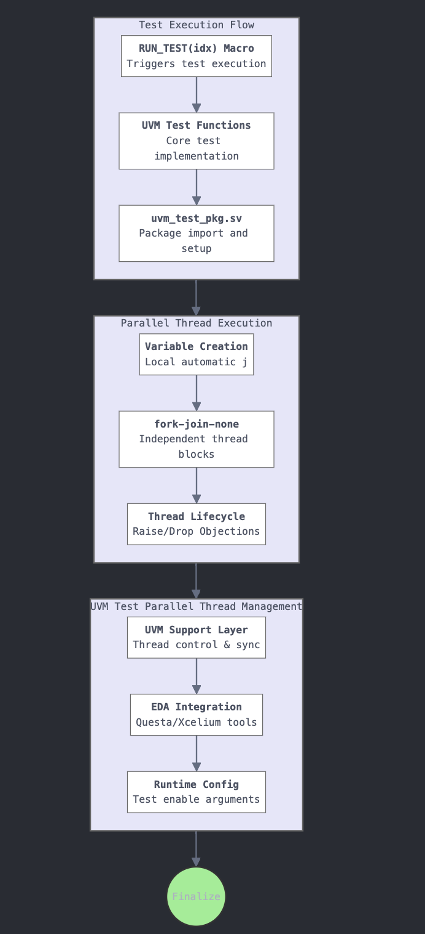

How do we implement Regwrite/RegRead or other functions which need to be be interfaced with the uvm testbenches ?

The architecture from C testcases to SV and then to UVM is how we set up our infrastructure.

First of all regWrites/regReads means they are packet transactions.
RegWrite requires device_id, address and data and the we need to know the response whether the transaction has reached it’s destination.
RegRead requires device_id, address and returns data from the UVM side.

The basic structure is to ensure all of these packets run smoothly from one end to other end. We don’t want to debug regwrite request packets with regRead packets with same packet id at a same instance.

The function add_buffer is meant to check

First ensure that whichever request is sent from the test.c (C side) has a unique buffer_id and there are request_buffer and the response_buffer. The request_buffer has the unique buffer_id, request_type, address (64 bits), device_id (which host/master is issuing it), backdoor or frontdoor request and data.

The response_buffer has the buffer_id and response of the request and then the data depending upon the type of packet.

Note:
Frontdoor Request is slow and takes time.
BackDoor Request is fast and that’s how we reduce time.

On the SV side, we first get the buffer id and then check the type of request it is.
After checking the type of request it is, we route the request to type of implementation that the request is. Depending upon the buffer id, we get the request_buffer from c to sv side.

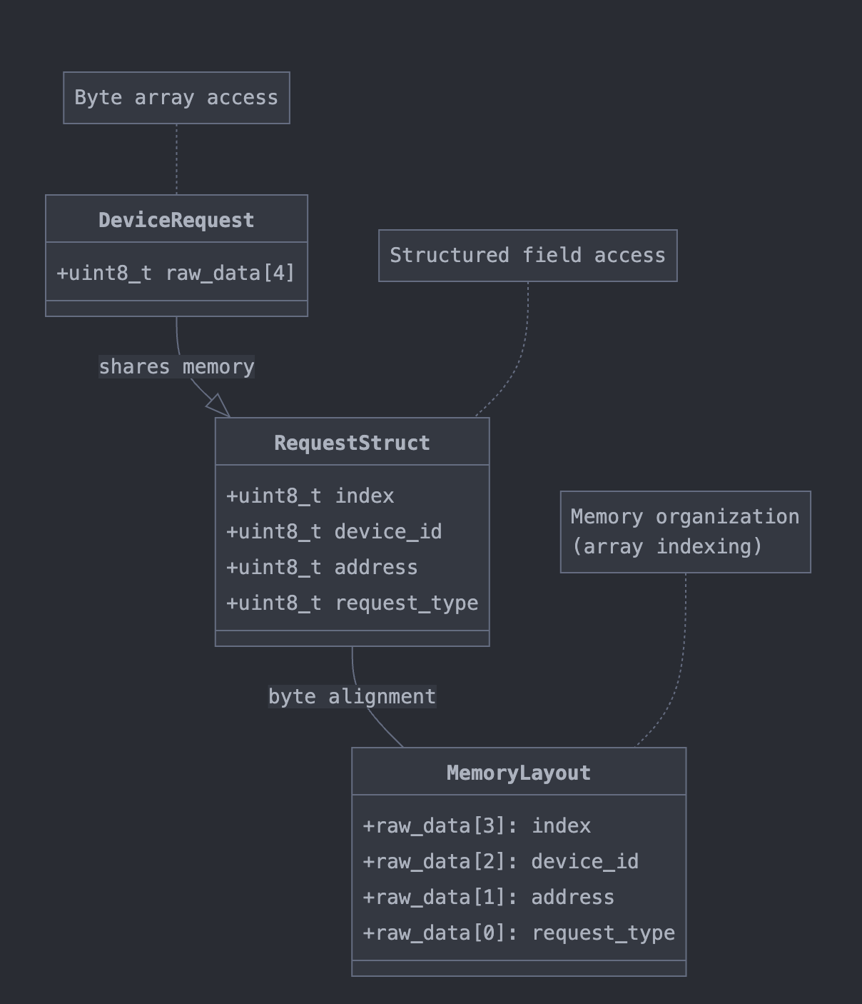

On sv side the buffer_id is taken.
Then the request_type is used for differentiating the kind of request SV’s got from the C testcase.

While implementing the type of request, we check whether it’s a valid request or a stray request.
We get the address, data and offset through multiple calls of getting the buffer_id and request_buffer arrays from C side.

The implementation of the request isn’t done here but done in multiple agents.
This implementation requires the address, device_id and depending on request, data is sent or received.

Then the response_buffer is filled by the task call of the implemented function. This fills the response_buffer present in the C side. After basic checks of bufid and whether the response for the packet is ok, we check for the rest of data.

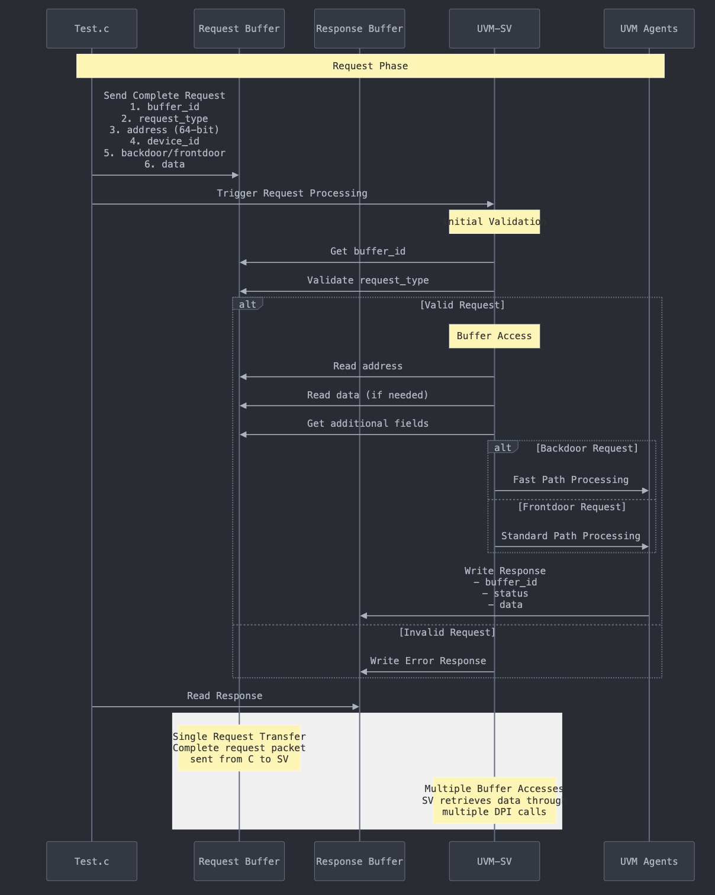

We have reached the end of SV layer. Now, the implementation of the request happens in the UVM.
For each request, a new request is created and sent to the requestor. All the fields are now filled in the request packet which is the uvm packet. Depending upon the bufid, request type, the C/C++ request is decoded and the UVM Request is created.
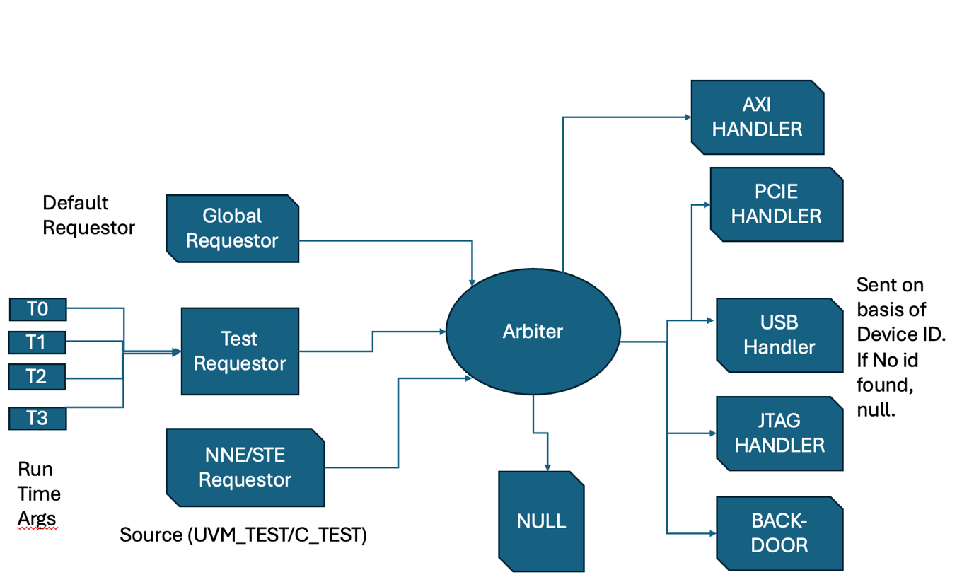
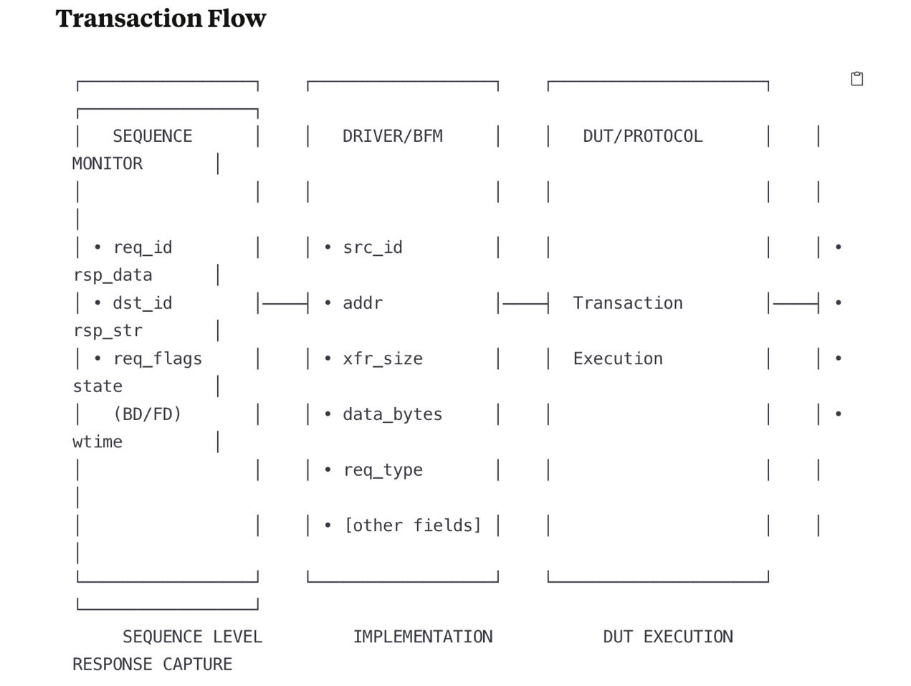

Backdoor:
Multiple Memories to have backdoor enabled.
How do we write backdoor for multiple memories ? How do we enable or disable them ?
How do we register them to all the Handler’s ?
All of the processing happens at the backdoor_handler level. (dv_top_bd_handler.sv)

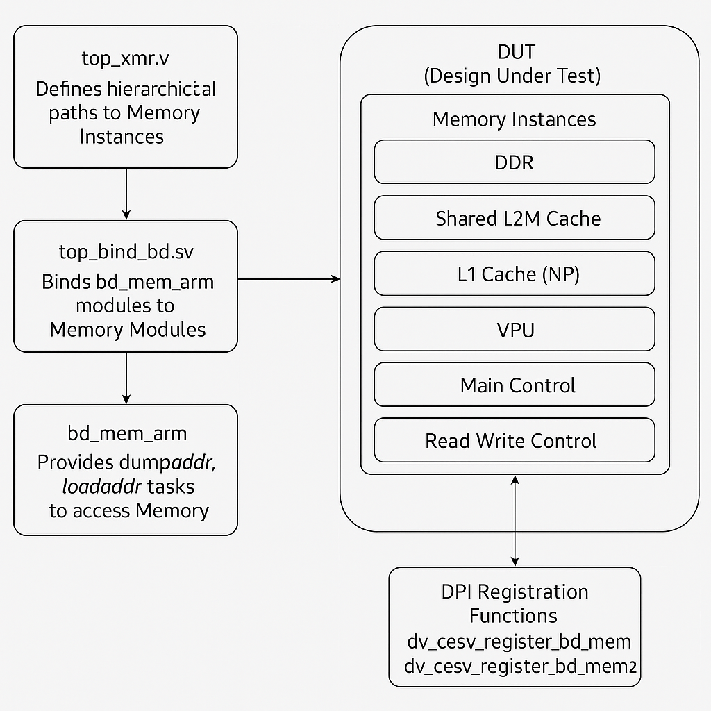

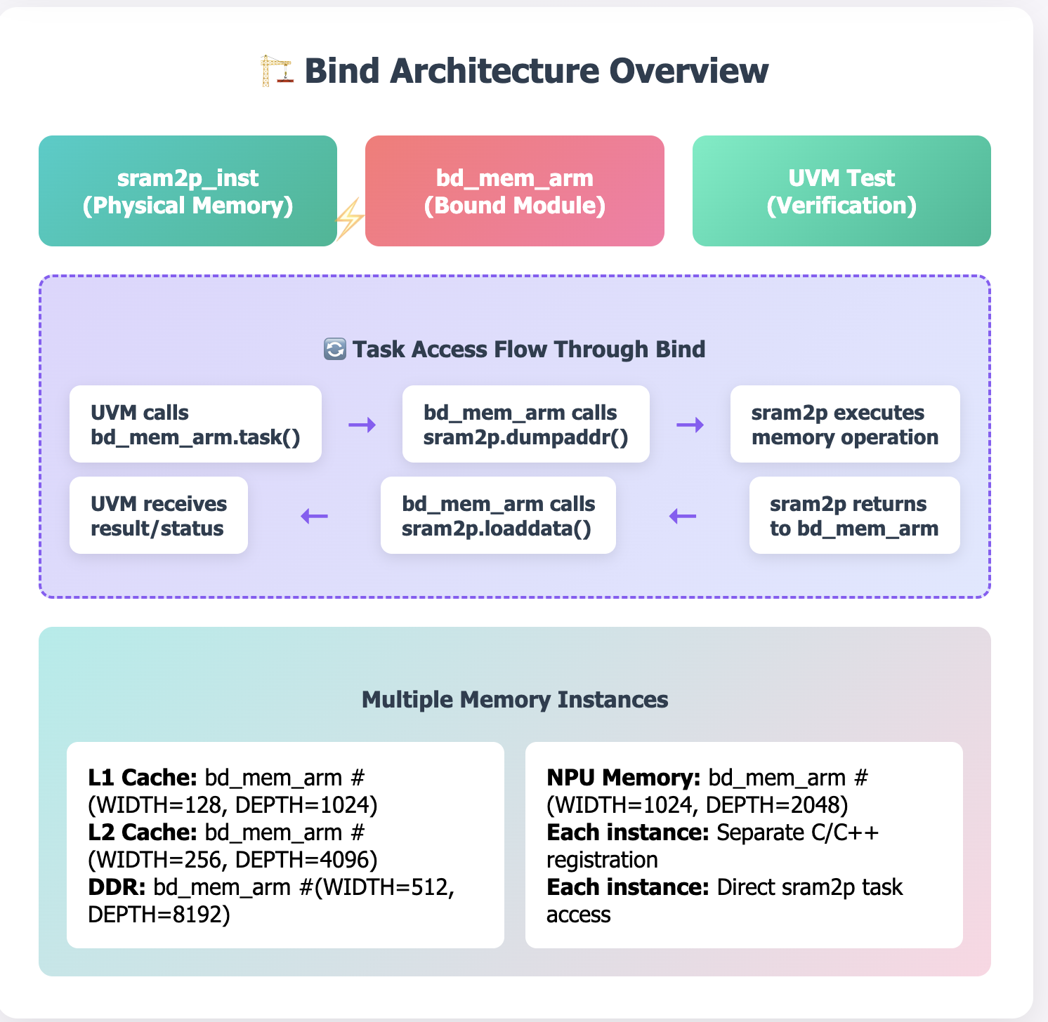

UVM TestBench files :
- Dv_uvm_tbcfg.sv : Add’s stub names
- Dv_uvm_env.sv :
Add stub values and push the values

Uvm_top_env:
- Configure AXI masters and slaves.
- How to configure them ? Configure based on the stubs values. If the stub is enabled, then add the kind of axi master type it is. Each of the different axi master’s information(address_entry, ) has to be logged in

RTL STRUCTURE :

wrap
└── pgt (FABRIC PACKETS) Fab clk ()
└── core (Local AXI Pkts) local module clocks Or Stub Here.
└── top
└── axi_if or Stub Here .
└── PHY
└── CTRL

We replace the Top with our Stub file i.e top_stub.sv.

For modules where you need to quickly create a placeholder with all inputs and outputs defined (outputs driven to 0). At the start of simulation phase, this deposits of all outputs to zero happens. When the BFM’s are hooked up, the BFM will be driving the values the values.

Passive Stub:
- Signals are driven by sequential drive (deposits).
- Used in Verification Flows.
- For multi-dimensional signals, we keep the module ports intact but the outputs which are driven from the module will be unrolled and driven to 0.
- The interfaces will be a bit different. We go to the interfaces and find the parameter being passed and then use the stub’s present in the specific interface stub. Axi_if.sp/mp axi_req is referring to the interface object and when we call the stub.

Configuration.sv files.
How to create stubs without modifying the rtl source code ?
We pass the Cfg_yaml files where we replace the source rtl with stub files without changing the file lists. This is a concept from LRM.
Cfg.sv

config TOP_NNE;
design work.tb_top;
cell ddr_core use ddr_core_stub;
cell axjt use axjt_stub;
cell pcie_top use pcie_top_stub;
cell usb_top use usb_top_stub;
endconfig

Methodology:
So in the optimization elaboration stage, instead of using the test bench top as my tb_top, I'll direct the elaboration tool to use my configuration as the top so that it'll go and replace the instances and builds that simulation snapshot.

Let’s say a module axi_if is present in top where we are stubbing. In the top_stub.sv the outputs of axi_if will be driven to 0.

uvm_config_db#(dv_qvip_axi_if_t0)::set(null, "uvm_test_top.top_env.axi_env", "MASTER_IF_PCIE", `XMR_PCIE_TOP.hst_m_if_0.axi4_if);

`BIND_AXI_IF_MASTER(
dv_qvip_axi_pkg::DV_QVIP_AXI_ADDR_WIDTH_T0, dv_qvip_axi_pkg::DV_QVIP_AXI_DATA_WIDTH_T0, dv_qvip_axi_pkg::DV_QVIP_AXI_DATA_WIDTH_T0, dv_qvip_axi_pkg::DV_QVIP_AXI_ID_WIDTH_T0, dv_qvip_axi_pkg::DV_QVIP_AXI_USER_WIDTH_T0,
16, "null",
hst_m_if_0,
axi_mst_clk,
axi_mst_aresetn, Reset to the VIP/
axi_m, ------------ RTL instance being used to bind.
`XMR_PCIE_TOP, - Hierarchy.
HS0MIDX). -- MASTER Number kept in ENVIRONMENT.

Fabric Interconnect Testbench:
Interconnect:
- New Form of Interconnect which has Load and store operations encapsulated as packets.
- Don’t care about the kind of processor we had in our system. It’s processor agnostic, (Risc-V processors,Xtensa Processors, Floating Vector Processing Units, Main Management Control Processor).
- Supports Byte level accesses, peer to peer messaging between components.
- In traditional systems, CPU itself would’ve a memory controller package. But in the interconnect that we verified didn’t have this problem and had different/own memory controllers.
- Fabric Interconnect was able to support, shared L2 caches, XSPI Nand , DRAM Interfaces. All the controllers on the chip were verified.
- The specifics of each protocol timings didn’t matter to this interconnect. (Like DRAM Settings, XSPI –Flash Timings under verification).
- So, this kind of helped in putting our power hungry cpu’s at a different place than our packing more memory subsystems.
- The question was how can we handle different kinds of traffic at the same time and how to verify it as well ?
- The question was to tradeoff for hardware management memory coherency over large traffic or use the software memory management coherency. Hardware Mgmt memory was initially easy to program but hard to manage the snoop traffic and exclusive access & other axi4 features were troubling.

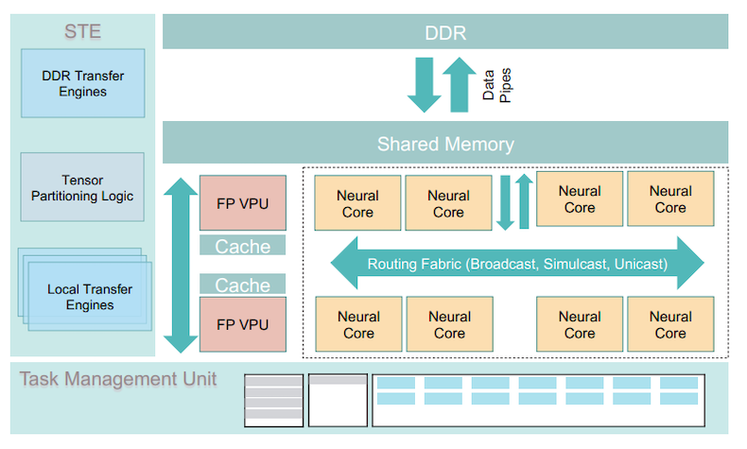

Different Feature’s or fifo’s being used in this Interconnect:

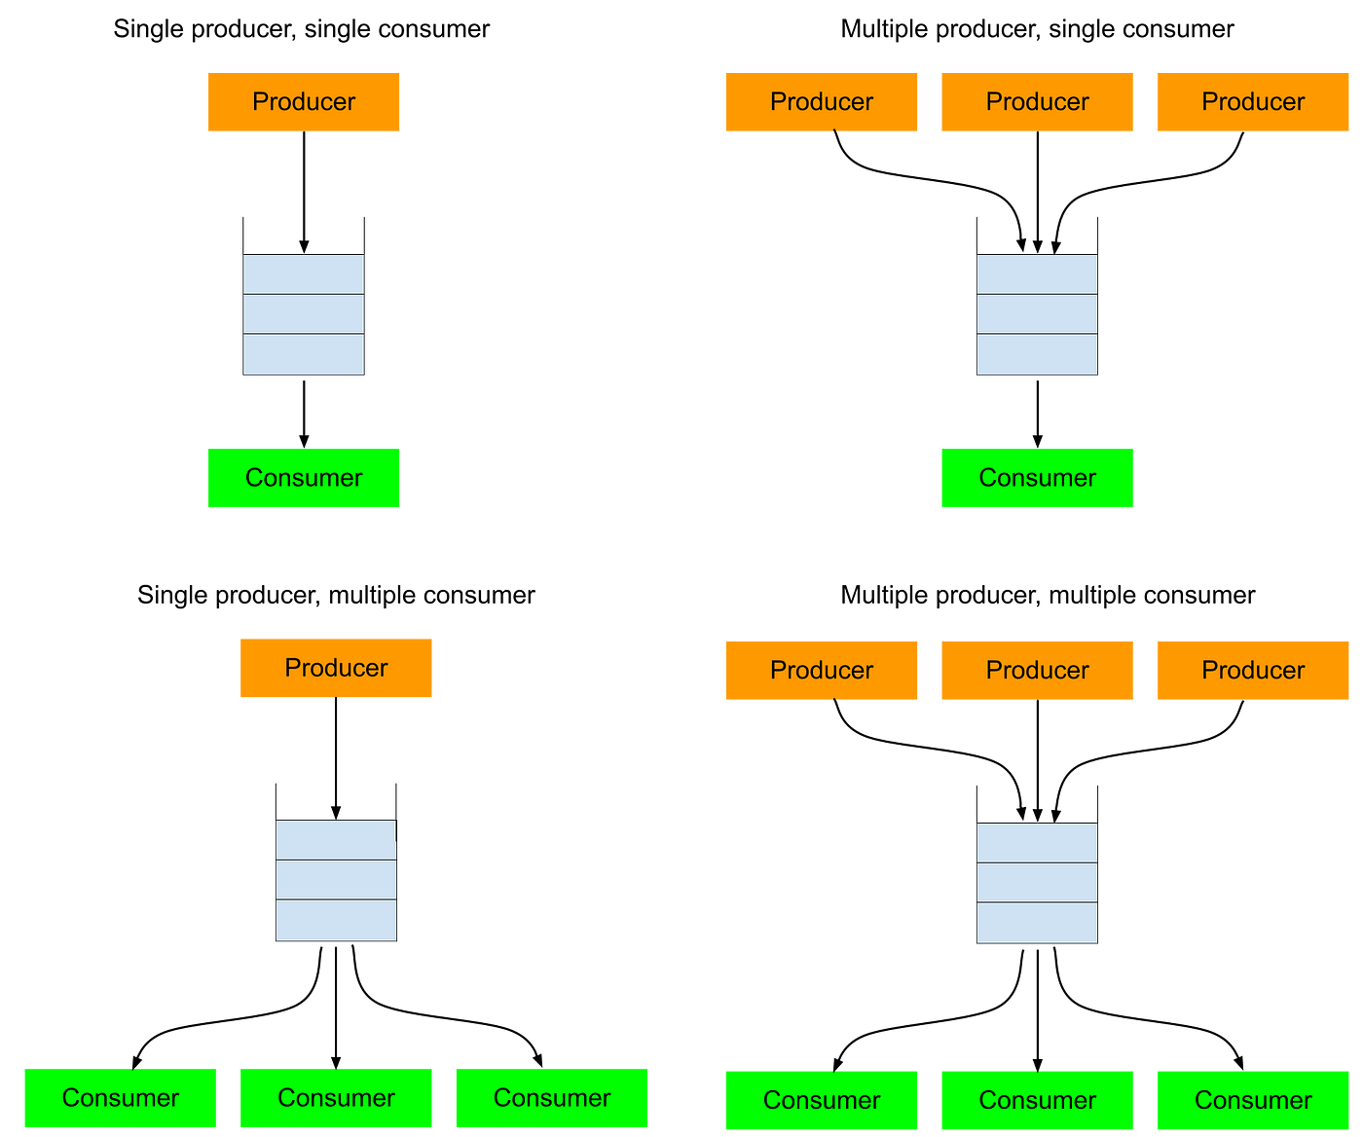

consumer_ptr ≤ producer_ptr ≤ consumer_ptr + fifo_limit

- Basic tests:
All the address map boundaries being covered and all slaves being included.
All the masters reading from the slaves (which they have access to.)
All the masters writing into same slave with different delays with minimum & maximum delays being configured through axi vip’s or axi environments. (Accessible)
Same testcase with some datachecks.
All the basic tests are done with AXI_INCR, burst_length = 0 ( 1 beat, 4 bytes).
Notes: So, Slaves having only one beat (i.e a word access mostly register slaves have to be removed since they are covered elsewhere and not applicable in random sequences i.e when doing it for multi beat transfers).
Now update the basic tests with different sequences of AXI bursts,size,length.
Different directed testcases of AXI burst length, size, burst type will have both randoms and directed testcases.

Flow of Runtime arguments:
- All the runtime argument addition and getting the parameters are present in the package dv_rt_args_pkg.
The package is imported in the dv_top.v and then used.

PLL CLOCK FLOWS:

